**Part 1. Modeling Planets & Texture Mapping**

We successfully modeled our planets using sphere meshes with texture mapping. A planet is represented using a Sphere class. The sphere contains attributes like mass, radius, position of origin, and a “prev” field which is used to calculate the initial momentum so that the planets won’t collapse to each other. The results are as follows:

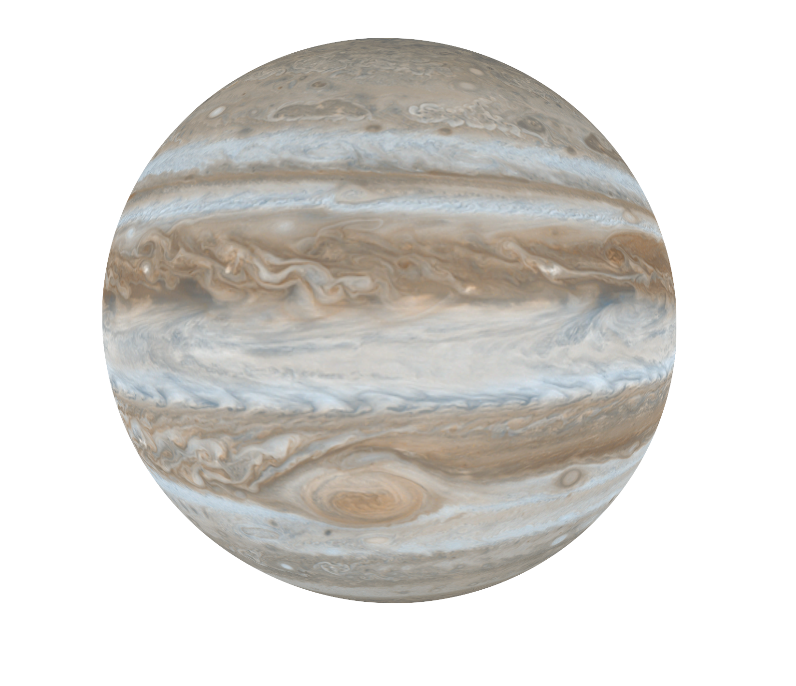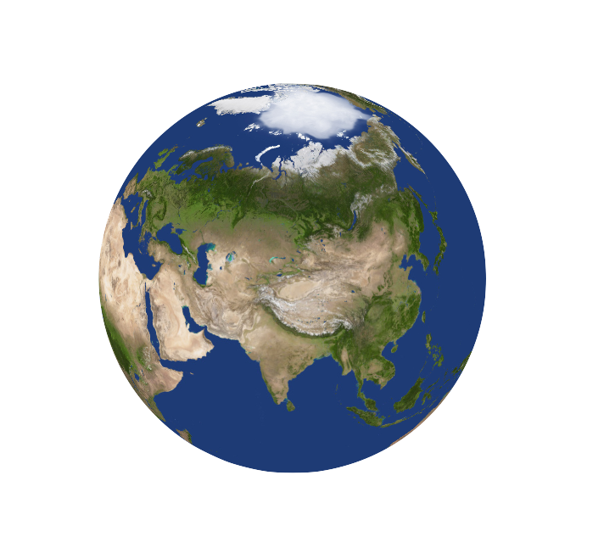

**Part 2. Creating the Universe Environment Lighting**

In order to simulate the effect that the planets are contained within a universe, we rendered a giant sphere that encloses the planets inside. Applying a galaxy texture will create the universe.

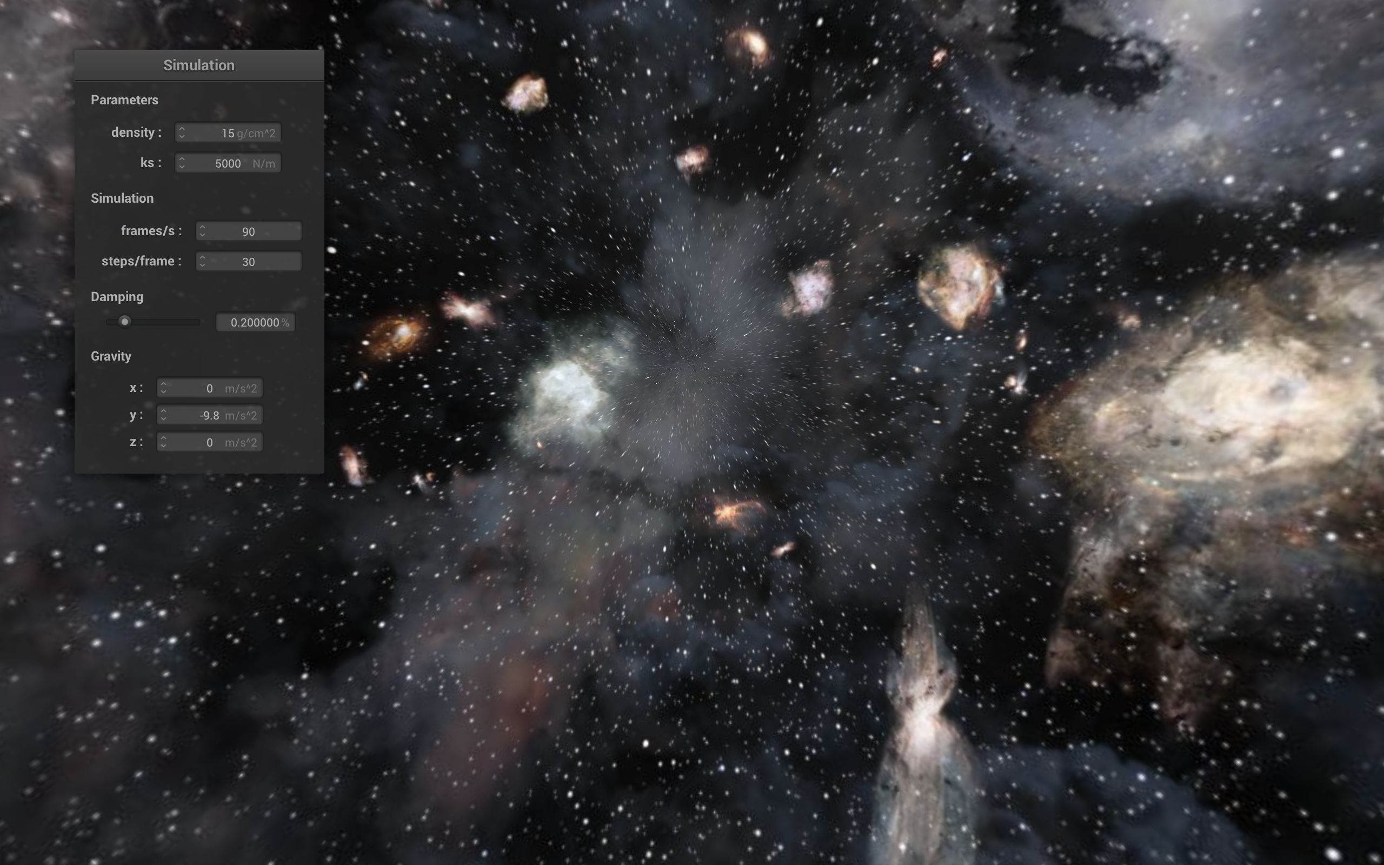

**Part 3. Simulating gravity**

We successfully modeled our planets using sphere meshes with texture mapping. A planet is represented using a Sphere class. The sphere contains attributes like mass, radius, position of origin, and a “prev” field which is used to calculate the initial momentum so that the planets don't collapse to the center. We use the famous universal law of gravity to calculate the forces exerted on each planet, and update the planets’ location using Verlet Integration.

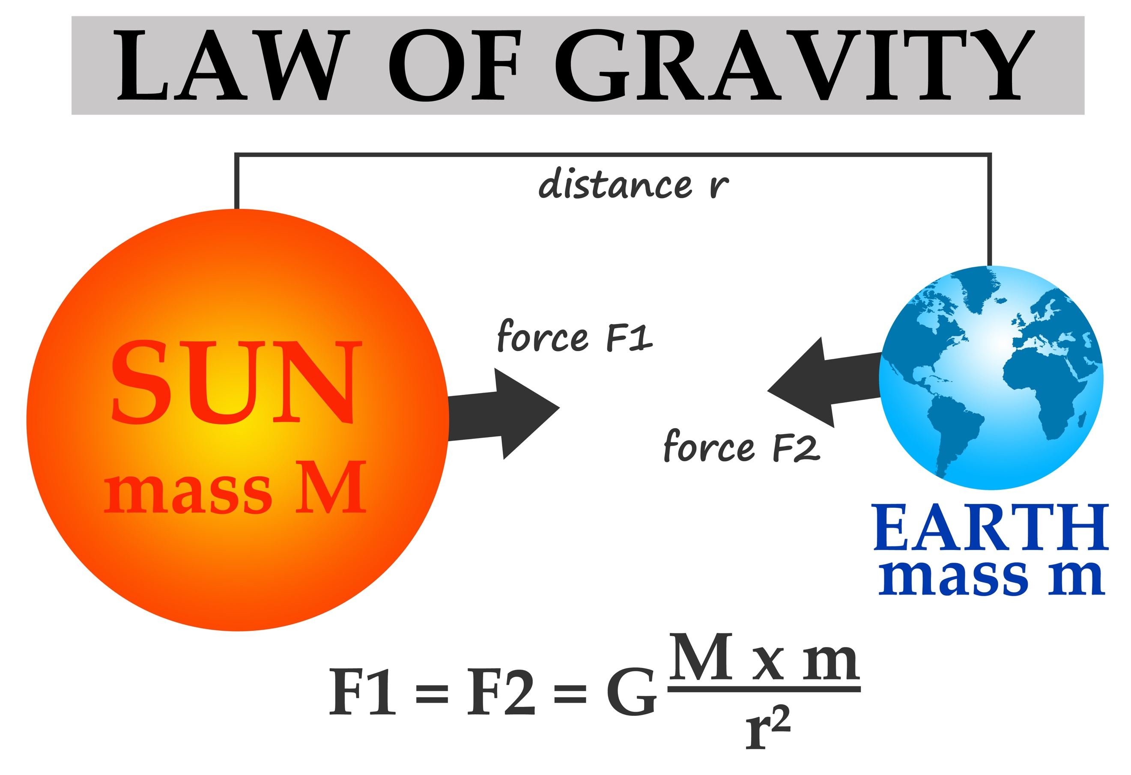

**Part 4. Putting Everything Together**

